
First Impressions
Team Report Form

Community Visited: Ellinwood, KS
Date Visited: a) Friday, 8/12/16; b) Saturday, 8/27/16; c) Tuesday, August 30

Pre-visit web search: How easy was it to get information on the community you were visiting? Did it accurately reflect what you saw? Did you have difficulties obtaining information on the community through a web search?

- It was fairly easy to find information online for Ellinwood. It was accurate to what I saw on my community visit.
- It was very easy to get information on the community and I felt it accurately reflected what we seen. There were no difficulties obtaining information through a web search and I really liked the cities web page. It was easy to get around and very informative.
- I did not have difficulty finding information about Ellinwood on the internet. I believe it was pretty accurate in the description of the community.

- The “Five-Minute” Impression: After taking a five-minute drive through the community without stopping, the following reactions were noted.

- Minimal signage to know where things are off of Main Street. Didn’t see signs showing where the park, schools, library, etc…. where are things? Well Kept, nice houses and neighborhoods, industrial areas on both east and west were rougher in appearance.
- Nice looking community. Really liked the brick streets, the old churches, the harvest decorations, and the majority of the properties were well maintained. Had that small town feel.
- The community does appear to be a bit spread out ­ could tell that they had recently received a large amount of rain. I loved the Wheat on the telephone poles driving into town.

The following observations were noted when entering the community from major entrances (signs, streetscapes, buildings, etc.)

- The streets are in good condition. Minimal signs –city limits sign and one large sign at the Y coming into town from the West. Nice metal church signs entering both sides of the community. Only observed Civic Organizations signage on the East. Buildings are mostly well kept; beautiful flowers are maintained in raised beds down town. The metal wheat on light poles is very cool.
- When entering the community from major entrances, we didn't notice any signs directing traffic to the schools, hospital, park, or pool. Entering from the east gave us an impression of kind of rundown. (example - the old house that needs torn down and the size of the weeds in that area) The area seemed to be industrial but a little TLC would make a huge difference on the towns overall appearance. The other entrances were very nice. Really liked the harvest theme on the light poles. Not a lot of streetscape. Liked the signs with all the churches on them.
- I did have some trouble with signage…….I kind of knew where to look for things based on my web search…...but had I not had that, there was some difficulty.

- Downtown Business Area
Describe the buildings, signs, infrastructure, etc.

- Clean and well maintained. Signs identify businesses nicely. The Gathering downtown had a chalk board sign on the side walk; a nice touch—the main reason we stopped in is because of the sign out on the side walk identifying what they had and what they were.
- Lot of great old buildings. Some could use a little maintenance. Fresh paint can make a world of difference. Could tell by the signs what kind of businesses they were. Were only in about three businesses in downtown because it was Saturday and everything was closed. Again, we really liked the harvest theme and it made you want to know more about it. Didn't get a chance to find out what condition the infrastructure was in. The old church to the north really catches your eye.
- The downtown was a nice area ­ was greeted kindly when I went into the Chamber Office to ask a few generic questions. It seemed to be kept up nicely.

Explain what type of businesses you observed and give a description of the variety and quality of merchandise displayed.

- There’s a variety of Businesses on Main Street: The Recreation Program, a Gym, 3 antique stores, Drilling office, Sauer Chiropractic and Sports Clinic, The Mane Focus Hair Salon, Kimple Gifts, Nextech Wireless, Sunflower Bank, Insurance offices, Kent Roth-Attorney, Electronic*Trade, The Chamber of Commerce, A tutoring service, The Gathering

- Most of the stores were closed but the antique stores had a great variety of items. We plan on going back to look at some of the other stores that were closed.
- Downtown was clean ­ not a ton of retail, but am sure it is hard being so close to Great Bend. The Antique Stores were not open, so we were not able to go in. I was greeted at most stores that really required something like that ­ and was helped when it was more necessary for me to ask questions.

Describe the customer service received when you entered those retail businesses. (Were you greeted? Did you have to ask for assistance?)

- Draney’s Antiques---very kind greeting when we entered, visited and make us feel welcome—nice variety of antiques, a neat store to look at.
The Gathering---great fun, welcomed us as we entered, great variety at the soda fountain, as well as a small selection of nice gift items.
Underground Tunnels (The Emporium was closed)—Joyce and Joe were very friendly and interactive, great time;
Wolf Hotel—can you say positive energy and enthusiasm? Chris met us at the door with a smile and treated us wonderfully.
The Chamber of Commerce—greeted as I entered the door, willing to share ideas and information on activities and businesses to visit in the area.
Ellinwood City Office—warm welcome, very informative on activities and eating establishments.
- We were in a couple of stores a while before we were greeted but once they did they were very friendly and we enjoyed talking to them. We did the underground tour and the guides seemed very knowledgeable and passionate about Ellinwood. We had a really good time and plan on going back.
- I was greeted at most stores that really required something like that ­ and was helped when it was more necessary for me to ask questions.

What public amenities were available (drinking fountains, benches, public restrooms, etc.)

- We did not observe drinking fountains down town, minimal benches were available -- the bricks around the flower beds could be used for sitting if needed. The flower beds are beautifully kept and maintained. The Gathering had restrooms for customers; I did not see public restrooms.
- Didn't really notice any drinking fountains or benches but it is possible I missed them. Wasn't looking for public restrooms either until we needed one. The building we were in did have restroom access. Trash receptacles were available in the downtown area.
- I did not have a problem finding parking ­ it was great for downtown, but of course with Dollar General the grocery store, you only could access the store in that location.

Comment on landscaping and streetscaping. Did you have difficulty finding parking? Could you access multiple services from where you parked?

- We didn’t have any problems with accessing or finding parking. We had multiple spots to choose from. Many businesses are within a short walking distance of one another in the downtown area.
- We didn't have any problem finding parking and we could access multiple stores from where we parked. There wasn't a lot of streetscaping but what was there is nice. The wheat bundles on the poles make a big difference.
- Landscaping was nice ­ but has been difficult to keep up with the rain!

- Other Retail Shopping Areas
Describe other retail shopping areas. Were the areas attractive and easy to access?

- Other areas are on the East and West Highway. There is a grocery store, Dollar General, the Meat Locker, Casey’s General Store, and the Pop ‘N Shop.
Pop ‘N Shop—The location of the sign made it difficult to know which building the business is in, the building itself was not marked. Easily accessible from the highway. There was not a greeting when entered, when approached- staff was very friendly and helpful.
Casey’s General Store—Very nice and modern. Not greeted at entry. Easily accessible from the highway. When checked out was thanked and told to have a good day, was not personable, just going through the motions. Entered a second time and was not acknowledged at all.
Meat Locker—Very nice and clean. Easily accessible from the highway. Was not greeted when I entered, as employees were busy helping others. Wide variety of products. Very polite and friendly at check out.
- Several convenient stores. Some nicer than others. Really didn't see any other retail shopping areas.
- No comments

- Industrial Parks/Commercial Areas
Is there a defined area where manufacturing industries could easily locate/expand? If so, describe.

- Areas on both the East and West sides of town appear to have industrial businesses and possible options for growth. These areas were not the best kept or most attractive/inviting as entering town.

- Wasn't sure in some areas if some of the businesses were still in operation or not so I am not sure what the possibilities would be in those areas as far as being able to locate or expand. The grounds maintenance and overall appearance of the area on the east side of Ellinwood along the highway takes away from Ellinwood's overall appearance. I know it is more of an industrial area but coming in from the east and having that as the first area you see creates a negative impression. Lot of weeds that you can tell have been there awhile.
- I think yes ­ there was a defined industrial space ­ but was spread out.

- Health Care Services
Comment on the availability and apparent quality of hospitals and emergency medical services.

- Hospital appeared in nice condition and well maintained.
- Hospital well maintained on the outside. I didn't go in. Have heard they have a good hospital and very good EMS Services. I don't have anything for availability and condition of facilities or long term care services.
- There was a hospital and clinic in the community.

Comment on the availability and condition of facilities for physicians, dentists, optometrists, public health and other healthcare providers.

- A medical clinic and a chiropractor/sports clinic were available. Both appeared to be well maintained facilities. I did not notice a dentist or optometrist office.
- No Comments
- No Comments

What long-term care services, assisted living or nursing facilities exist in the community?

- There was a nursing home facility on the north end of town across from the football field. Appeared to have a few apartments attached as well.
- No Comments
- No Comments

- Housing
Give a brief description of the existing mix of housing stock. Does the local market have housing that would appeal to all income wages? What challenges do you see in regards to finding acceptable housing? (Neighborhoods, size, properties for sale, etc.)

- There were homes for sale with in different neighborhoods throughout town. Of course prices were not posted, but I would say yes there are various price ranges, looking at size and styles of homes. I did notice a sign or two also for sale by owner.
- Seen on the internet that they have about 10 houses for sale in different price ranges. I also seen a couple for sale by owner. Looked like there might be areas to develop if they needed to. Lot of nice looking neighborhoods but it didn't look like there were many empty lots for sale to build on. I did not contact anyone to get more information on available properties to build on or contact anyone about rental properties.
- There was a variety of housing for sale that varied in price. So, I am not sure there would be a problem purchasing a home.

What kind of rental properties did you observe for persons interested in building or simply living in the community prior to buying housing?

- I did not observe any homes with FOR RENT signs.
- No comments
- The City website provided great information for housing questions!

- Schools
What schools are present? (Head Start, Preschool, K-8, High School, Post-Secondary, etc.) Do the schools appear to be adequate in size? Are the buildings and grounds well- maintained?

- I observed the Elementary School and the Middle School/High School. Grounds were nicely maintained and looked to be well kept. I also observed a St Joseph School behind the Catholic Church, nicely kept and maintained as well.
According to a brochure I picked up there is also a St John Lutheran Pre-School and daycare, I did not observe this on my visit.
Barton County Community College is 10 miles away in Great Bend.
I also noticed a tutoring service of some kind located near the Chamber of Commerce.
- There is preschool to high school and the schools appear to be adequate in size. The schools exterior and grounds look well maintained.
- Schools looked good ­ we notice a preschool, Grade School and High School.

Were you able to find print information in the community that helped assess the quality of the educational system?

- I picked up a brochure that state what is available for education. I did not find information to tell me about the quality or any detailed information regarding the educational system.
- I did not come across any information that helped assess the quality of the educational system.
- No Comments

- Childcare
What childcare service are available? Is it affordable?

- The brochure stated there was a St. John Lutheran daycare that I did not observe. There was a large child care center on North Main Street. We observed a large group walking from the center to the Elementary school playground, with adequate staff and children well behaved. If other providers are available they were not observed. Costs are unknown.
- There is St Johns Child Development Center in Ellinwood but I am not sure what it costs. It looks well maintained and is in a nice location. Also very easy to find on the website. Didn't find any other information on daycares.
- No comments

- Faith/Religion
Comment on the number of denominations and the physical appearances of the churches represented in the community. Did you observe any evidence of church- sponsored community services?

- Nice metal signs one east and west entrance with churches posted:
St. Joseph Catholic Church---beautiful older limestone church—well-kept and maintained grounds. Located on main street.
First Baptist Church--- did not observe, from the city webpage it stated that this church is south of town in the country.
Calvary Baptist Church---did not observe.
United Methodist Church--- Nice appearance and well kept. Visible from the highway.
St. John’s Lutheran Church---Nice appearance. Has a large youth center on the grounds.
Immanual United Church of Christ---Nice appearance and well kept.
I did not see anything showing upcoming church sponsored community activities.
- There are several different denominations in Ellinwood. The churches looked very well maintained and the buildings looked in good shape. The one church really stood out but they were all nice on the outside. I did not observe any evidence of church sponsored community services.
- The sign entering the community was nice to see what Churches were available in the community.
- Civic
Tell about the variety of nonprofit organizations and clubs within the community.

- Lions Club, Rotary, Knights of Columbus, Optimist Club
- I saw the chamber of commerce office but I do not remember seeing anything else about their organizations.
- No Comments

Did you observe any evidence of civic organization activity?

- While at the City Park I observed that the benches were donated by a project done in the past by the Lions Club.I observed flyers around town about the Rotary Club working to complete a project for a Splash Pad.At the gathering I found that this the meeting place for the Rotary Club and the Optimist Club.
- I did not observe evidence of any civic organization activity.
- No Comments

- Public Infrastructure
Comment in general on the streets, street signage, sidewalks, parking, lighting, restrooms, landscaping, and streetscapes in areas other than downtown.

- Streets and street signs were adequate. There were restrooms at the park, thinking those were only restrooms not within a business. Yards were well kept. The metal wheat sculptures on the poles were very nice and eye catching.
- I think it is great that they still have some brick streets and the other streets seemed to be in good condition. Parking availability was good. Street signs were good but didn't see any signs telling you how to get to the schools, parks, ballfields, Hospital, or pool. Looked like there was good lighting everywhere. I didn't get any information on the water or sewer system.
- No comments

Did you observe land-use planning?

- There was one spot on Main Street being developed.
- I did not observe any land use planning.
- No Comments

Comment on city/town hall (How were you received? Was there information about the town available?)

- I picked up a couple of pamphlets/brochures as I walked in the door of City Hall. I was greeted as I entered the door and was treated very kindly. The ladies were very willing to answer questions and offer suggestions on activities for myself and children, as well as, locations to eat lunch.
- I was there on a weekend and City Hall was closed. The City has a nice website.
- The chamber was awesome and very helpful.

Police/fire protection:

- The Barton County Sherriff and local Police officers were highly visible throughout the day. They would often give a friendly wave.
- Looked like a nice fire station and I did read some information on the website about the fire and police services.
- I did notice both fire/police protection.

Library:

- I did not see any information about the town. There was a small bulletin board by the door that had a couple of flyers about the Rotary Splash Pad and one other notice. We were not greeted when we entered. As we stood looking lost we were directed towards the children’s area. After time spent in the children’s area, we initiated interaction and were treated pleasantly and provided answers to our questions.
- If I read the sign correctly, The School Library and City Library are the same.
- I spent the majority of my visit here ­ I had forgotten it was a combined library and we are interested in doing something similar in on my of branch communities. The staff was very helpful ­ answered all of my questions. The librarian was also able to branch off and talk a little bit about the Library Foundation ­ which is similar to what we are trying to get started here in Cimarron, but a Community Foundation.

City parks (walking tracks, ballparks, playgrounds, sports complex)

- The park was beautiful. It had basketball courts, covered area with picnic tables, and a variety of older and newer playground equipment. It was great to have swings and equipment that could be safely used by toddlers. The park had nice benches and a water fountain. The park is located near the city pool, as well as, the school football field. The pool was very nice as well. It was not open when we were there, but it was nice to see the small toddler pool, as well as, the handicap chair for accessibility to the pool.
- Nice Parks and Playgrounds. Nice track, football fields, and tennis courts. Looked like they were working on the pool or adding to it. Lots of ballfields around town. The Cemetery was well maintained.
- City parks were nice ­ but would have liked better signage.

- Recreation/Tourism
Is the community well-known for any particular attraction or event? Do they have a community slogan that capitalizes on that asset?

- Ellinwood is well known for the Underground Tunnels and the Wolf Hotel. They provide great History of the community and the area.
- They have the underground tunnels, the yearly after harvest festival, and the haunted hotel. Did not hear if they have a town slogan.
- The hotel/underground tours is what I believe they are noted for ­ we were unable to take a tour ­ both people were out of town (not a scheduled day) but VERY helpful and nice on the phone.

Did you see any indication of significant events taking place in the community that would be of interest to both visitors and residents?

- NA
- Significant events would be the tunnel tours, the after harvest festival, and the haunted hotel.
- No comments

Elaborate on any significant natural or manmade features that have the potential of drawing people to the community.

- Ellinwood is close to the Cheyenne Bottoms and the Quivera National Wildlife Refuge; in addition to the Underground tunnels.
- The potential to draw people to their community would come from the tunnel tours, the after harvest festival, the haunted hotel, schools, golf course, recreation programs, and the small town atmosphere.
- No Comments

Is there an obvious visitor’s center, chamber of commerce office, main street office, or other facility that serves the needs of visitors? Comment on the staff, facilities, signage, visibility, etc.

- There is a city office directly off of Main Street. Their facilities and staff were very nice. This facility was easy to see if driving North on Main Street. The Chamber of Commerce Office is on Main Street. It sets back and I drove past in 3-4 times before it caught my eye. The staff was very nice and answered questions and provided options for activities. I would not have known about either of these facilities without driving on Main Street to find them; there was not signage to lead me to them.
- There is a chamber of commerce office downtown. It sets back just a bit from the surrounding buildings so I didn't catch it right off but once I got closer I could read it across the windows. I was there on a Saturday and a lot of places were closed. I hope to go back during the week sometime in the near future.
- Yes ­ I was able to find both Chamber/City office.

Are there any restaurants, specialty shops or attractions that would bring you back to this community in the near future?

- We ate at the Lone Wolf and it was very good. The staff was excellent and very kind. We would like to come back to the Wolf Hotel as it continues renovation and growth in business.
- We would like to come back and hit the antique stores again. We also want to check out some of the other stores that were closed and stay at the Wolf Hotel and go to the underground bar. Would also like to see what goes on at the after harvest festival.
- Hotel/Underground Tours.

- Wrap-up
What are the most positive things you observed about the community?

- This small town has a lot of visible pride in its community. The inside of town is maintained well. There are several businesses that allow shopping, services, and a majority of needs to be provided for at home without traveling. Overall a nice community that I would be willing to visit again.
- Ellinwood is a nice community. Nice schools, churches, golf course, playground, park, etc.
- I would definitely look at Ellinwood to live if I had a job in Great Bend. I thought the community had a lot to offer.

What are the biggest obstacles/challenges facing this community?

- Concerns for the employee attitudes to the businesses we went to on the highway. Greetings are important; it will help make people look into your community more. The opportunity for house rentals and employment may be a concern. I did not see rentals or employment opportunities posted throughout our visit.
- Some challenges would be housing, getting people to stop and see what they have to offer.
- For me ­ signage and I think it is challenging being located so close to Great Bend.

What will you remember most about this community six month from now (positive or negative)?

- The Wolf Hotel made quite an impression on our family, not only through the facility, but through Chris as well. His energy and excitement was truly contagious to those around him. Unfortunately I will probably also remember the negativity at the Casey’s General Store. It is important to treat customers kindly and encourage them to return. If I go to an establishment that is not friendly and openly engaging, I will likely not return.
- Six months from now I will remember the tunnel tour, the history of Ellinwood that we learned on that tour, and our guides for that tour.
- Library!



First Impressions was developed by the University of Wisconsin-Extension and adapted for use by K-State Research and Extension. Restructuring made possible through a partnership with the Dane G. Hansen Foundation.

Kansas State University Agricultural Experiment Stations and Cooperative Extension Service
K-State Research and Extension is an equal opportunity provider and employer. Issued in furtherance of Cooperative Extension Works, Acts of May 8 and June 30, 1914 as amended. Kansas State University, County Extension Councils, Extension Districts, and the United State Department of Agriculture Cooperating, John D. Floros, Director.

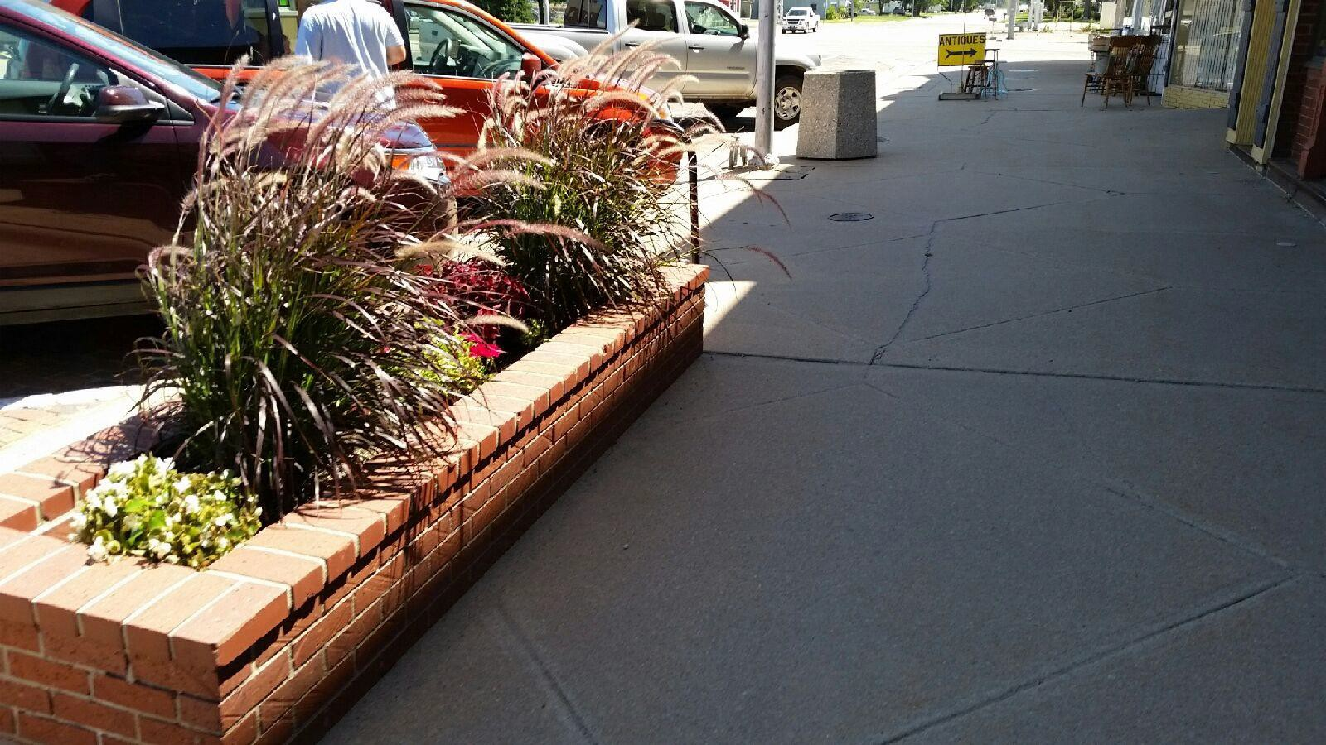

These are beautiful! Makes the downtown area look very nice!
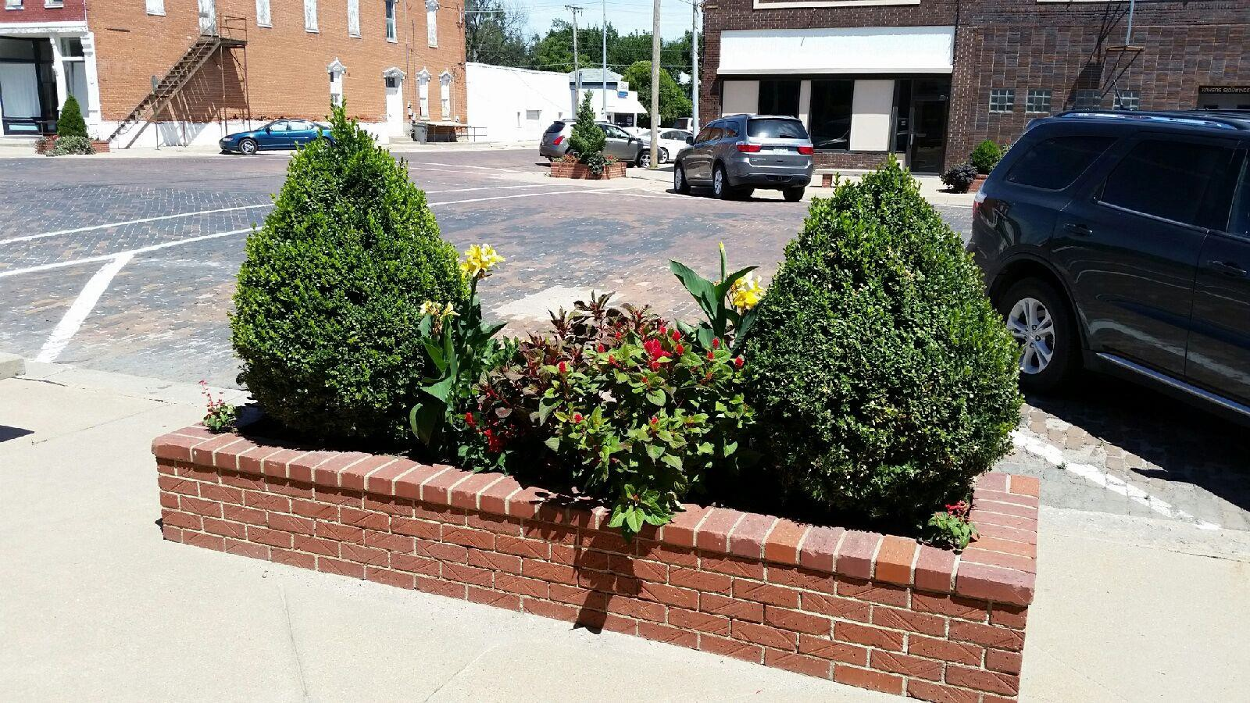

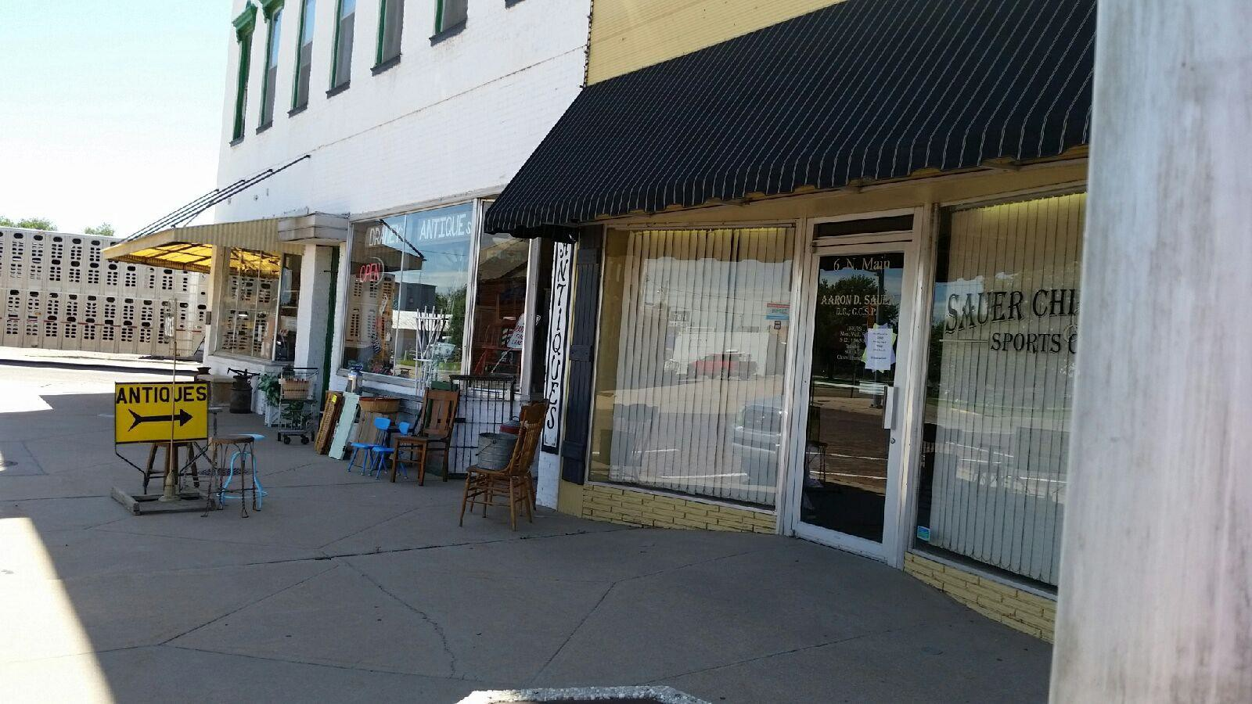

The sidewalk signs are nice! I think they help draw attention to the businesses and help tell what they have available.
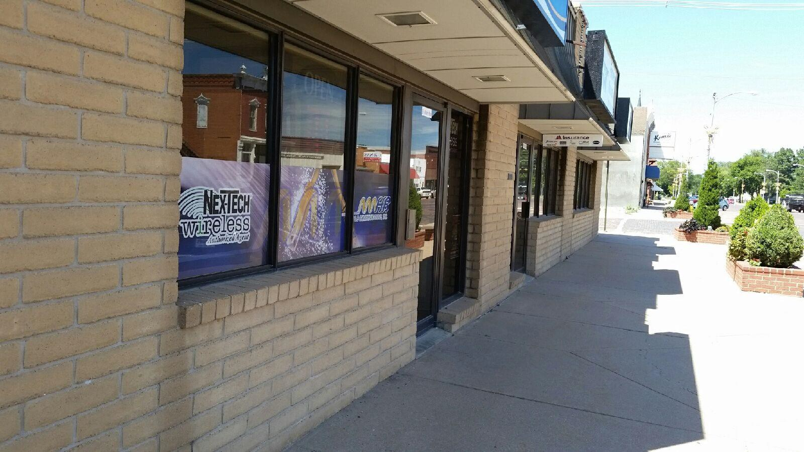

Looking down the street, it’s so nice and clean. Well taken care of community.

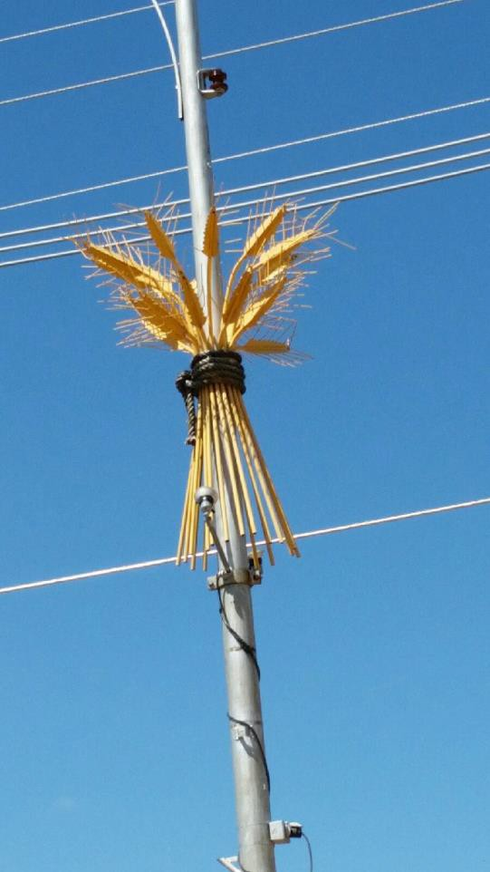
I love the wheat! Such a neat idea and a way to dress up the town!

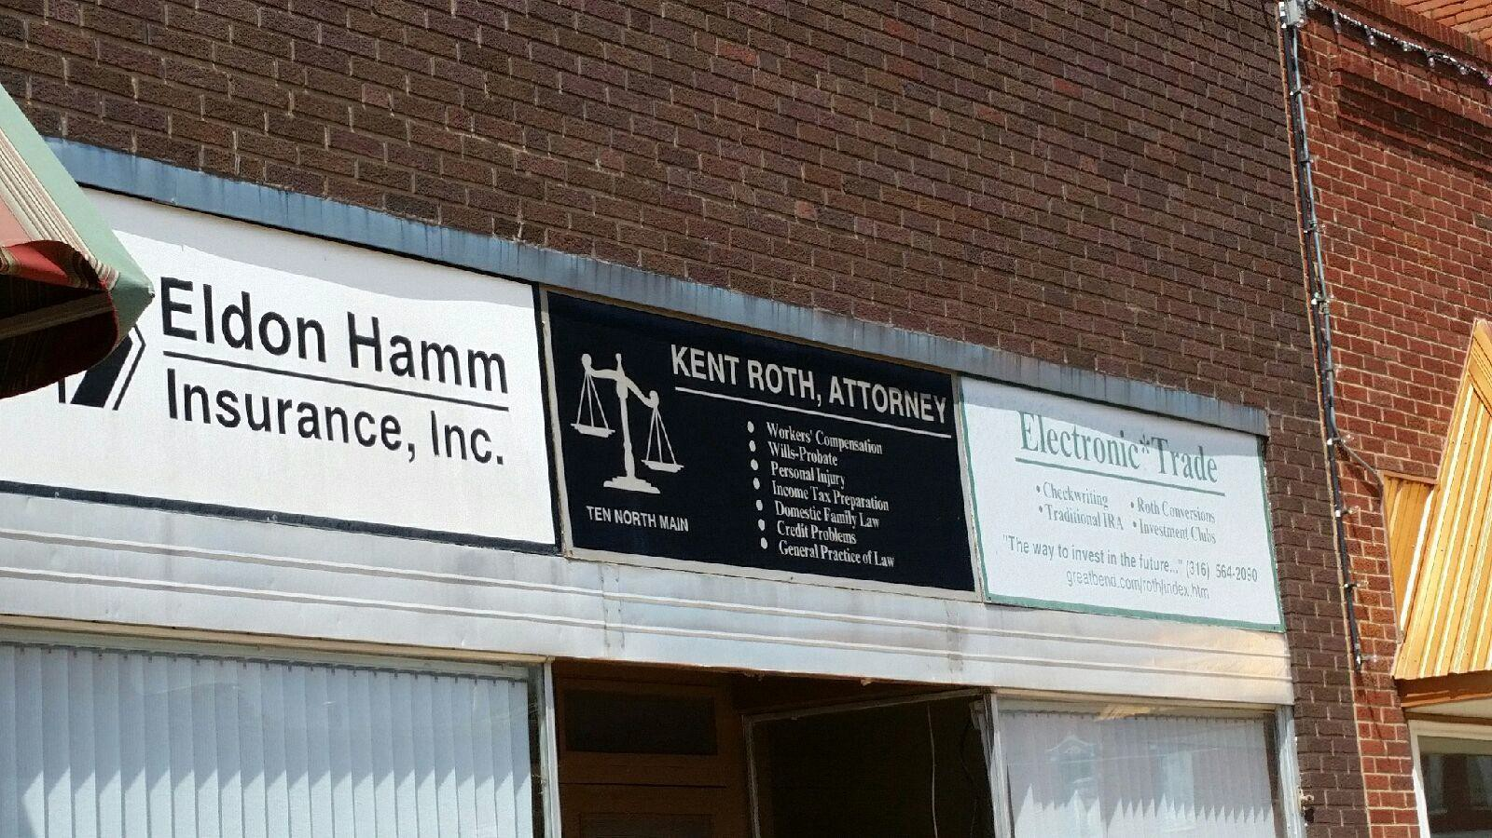

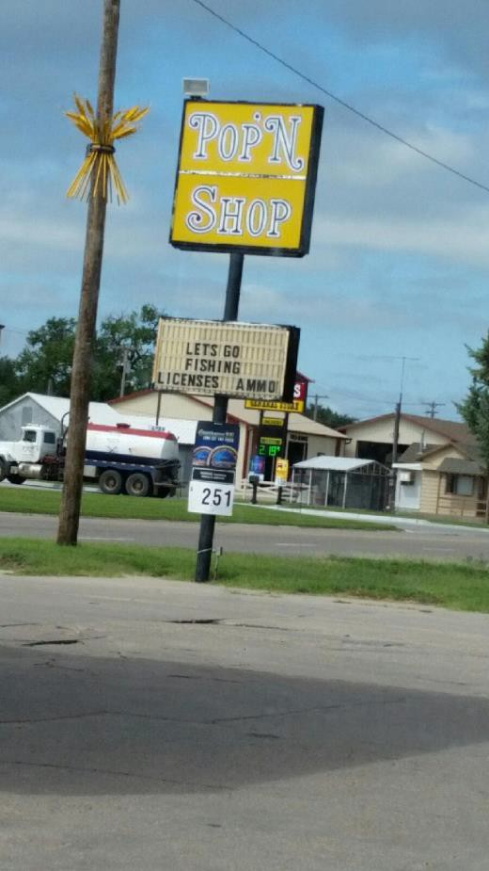
This is a location I would encourage to add store front signage. Just to the right of the sign is a house structure. It’s difficult to know exactly where the Pop N Shop is.

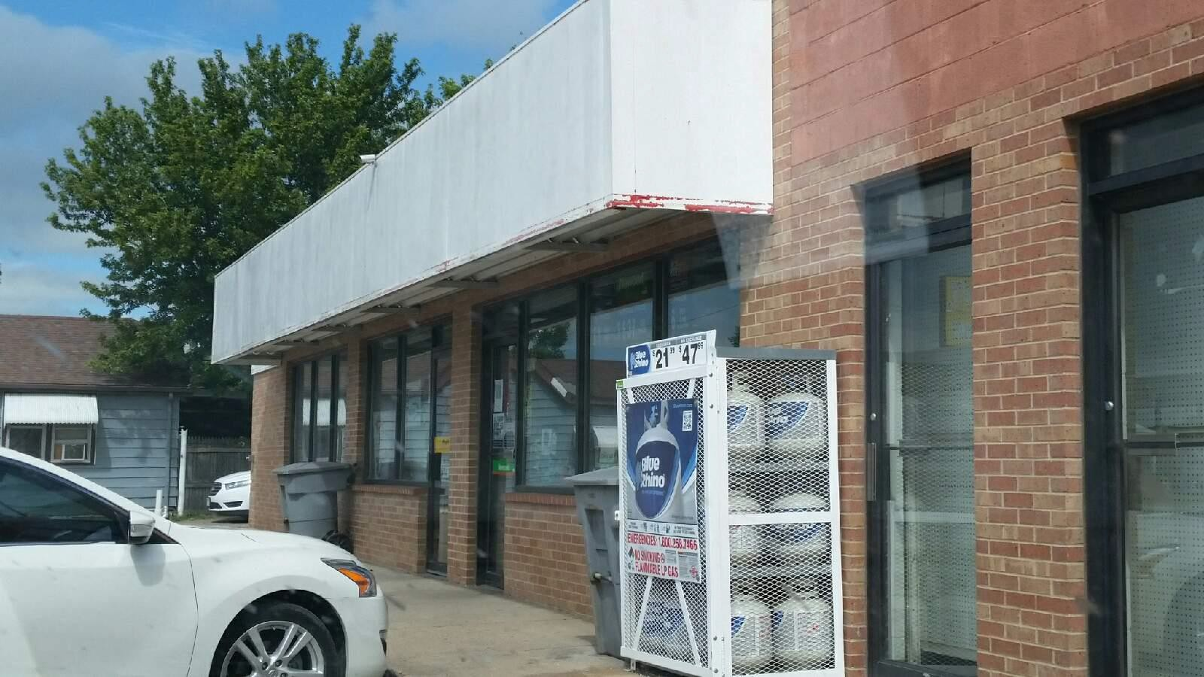

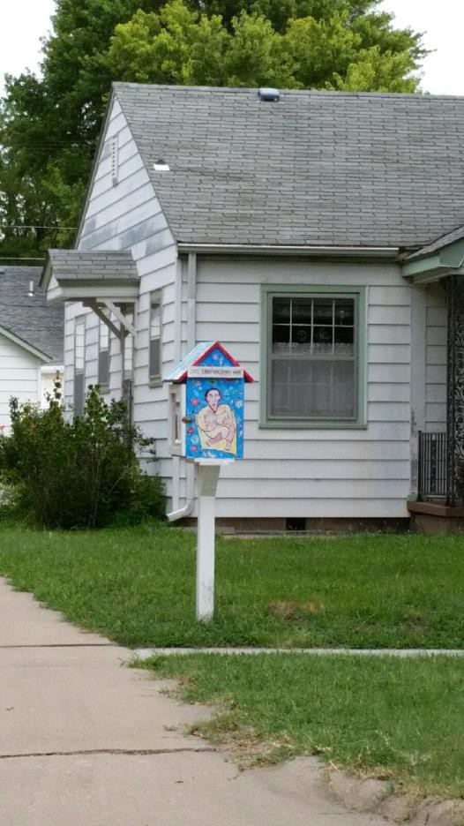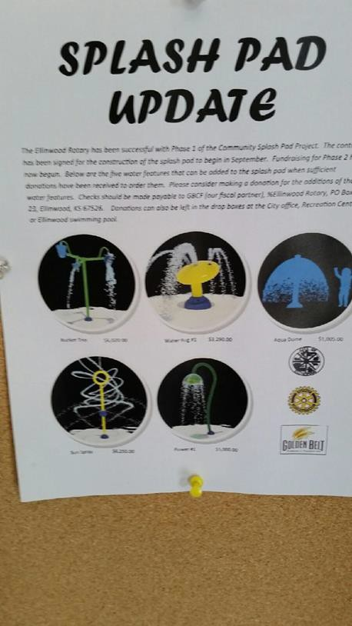

A free neighborhood library??? This is just around the Community project being completed by the
Corner from the library. The librarian did not know Rotary Club. A fun and exciting addition to the
Anything about it, but I think this I a great idea. Community.

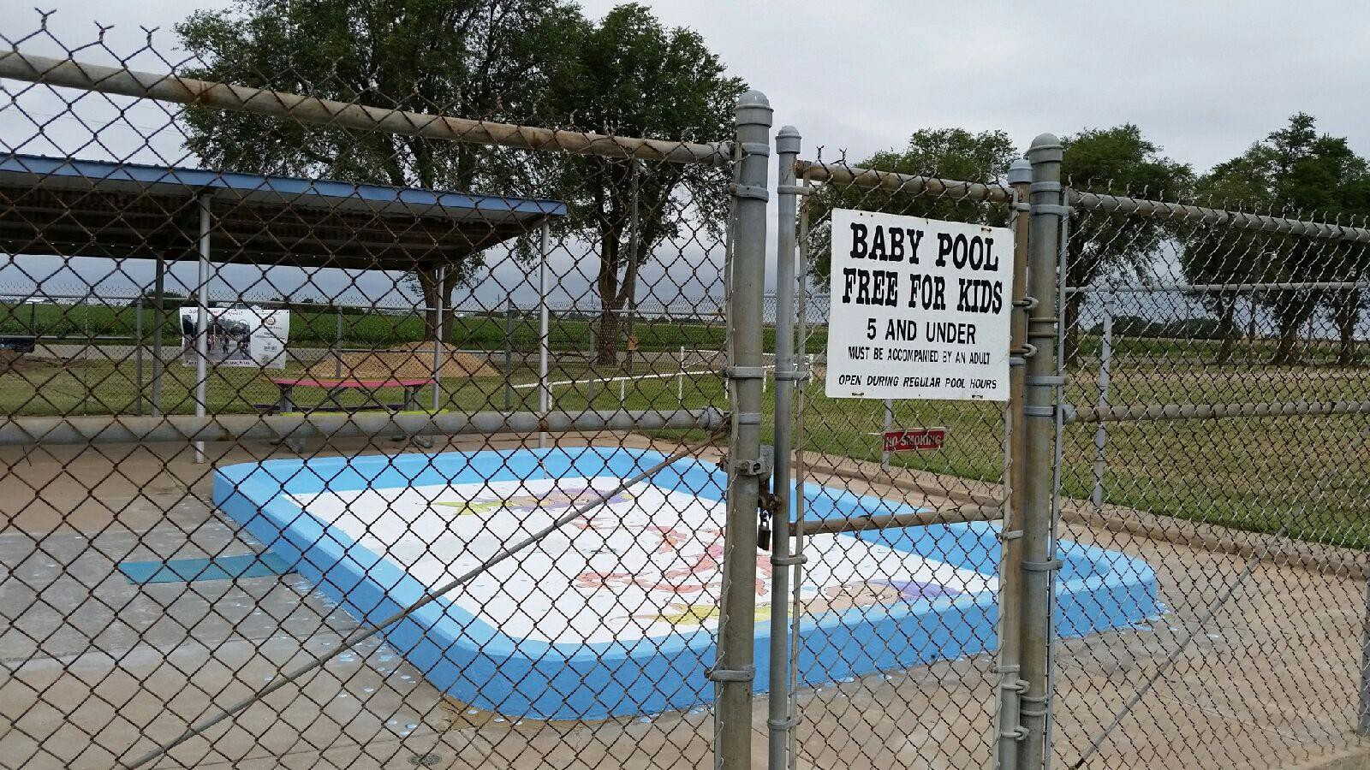

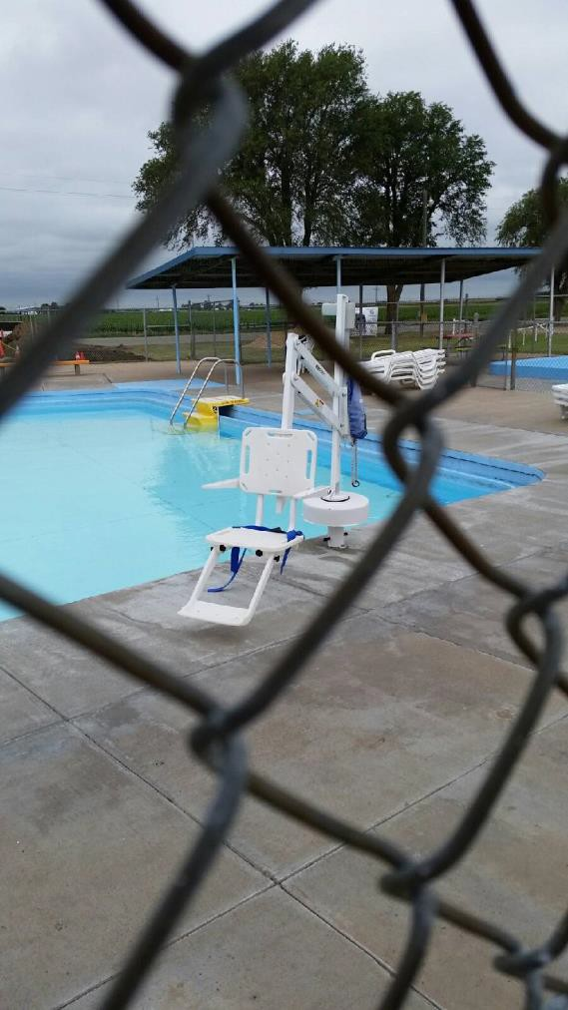
Great benefits for small children and those with disabilities.

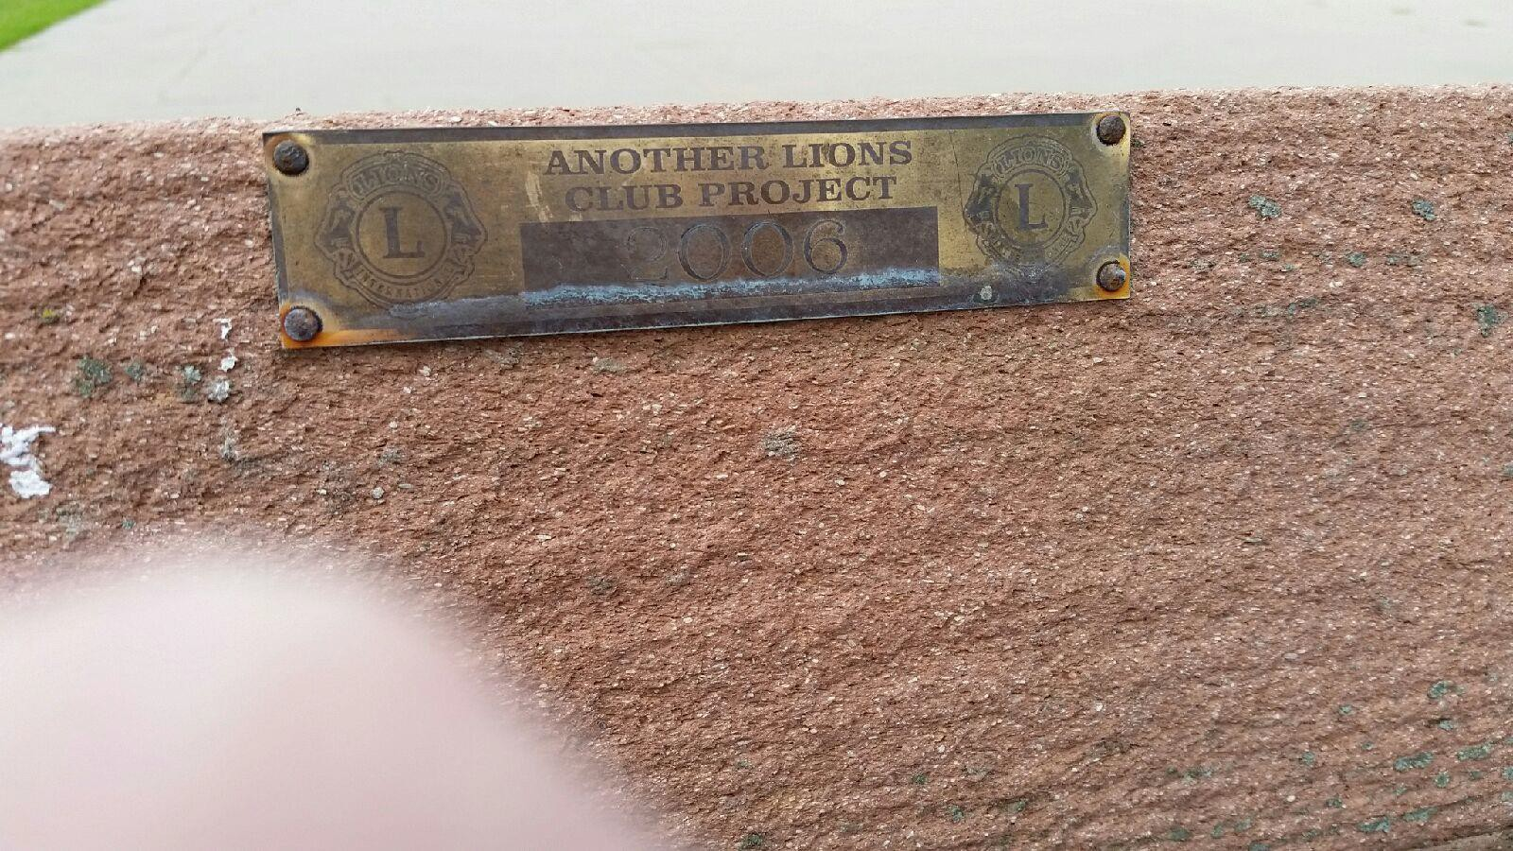

Lion’s Club involvement within the community. Great benches that add a lot to the Community Park.

